**USER STORIES**

**CUSTOMER RELATIONSHIP MANAGEMENT**

**1.Introduction**

**1.1 Purpose**

1. As a Sales Representative, I want the CRM to automate routine tasks like contact

information updates, allowing me to focus more on strategic sales activities.

2. As a Marketing Team member, I want the CRM to facilitate real-time

collaboration on marketing campaigns, ensuring timely adjustments for optimal

results.

3. As an Administrator/Manager, I want the CRM analytics to provide actionable

insights for quick decision-making, aiding in the achievement of business

objectives.

4. As an IT Department member, I want the CRM to seamlessly integrate with our

existing systems, ensuring a smooth transition and continuity of operations.

* 1. **Scope**

1. As a User, I want the CRM to handle a large volume of customer interactions

efficiently, ensuring no data is lost or delayed.

2. As a User, I want the CRM to support integrations with widely used enterprise

systems, such as ERP, to ensure a unified business process.

**2. Business Objectives**

**2.1 Core Objectives**

1. As a Sales Representative, I want the CRM to provide predictive analytics for

identifying potential sales opportunities and customer churn.

2. As a Marketing Team member, I want the CRM to integrate with popular

marketing automation tools, streamlining lead nurturing and campaign tracking.

3. As an Administrator/Manager, I want the CRM to comply with data protection

regulations like GDPR, ensuring the security and privacy of customer data.

4. As an IT Department member, I want the CRM to undergo regular security audits

and vulnerability assessments, maintaining a secure environment.

**2.2 Stakeholders**

1. As a Sales Representative, I want to actively participate in the creation of reports

that cater specifically to sales insights.

2. As a Customer Support Team member, I want the CRM to have a ticketing system

that ensures efficient handling of customer support requests.

3. As an Administrator/Manager, I want the CRM to provide role-based access

controls that align with the organization's hierarchy and security policies.

4. As an IT Department member, I want to be involved in the design of API-first

architecture, ensuring efficient data communication.

**3. Features**

**3.1 User Perspective**

**3.1.1 Contact Management**

**3.1.1.1 Add/Update Contacts**

1. As a User, I want the CRM to automatically validate and suggest corrections for contact

information to minimize errors.

2. As a User, I want customizable fields to include unique identifiers for each customer,

aiding in personalized interactions.

3. As a User, I want the ability to track the history of contact updates for audit purposes.

**Acceptance Criteria:**

**Given:** Users have logged into the CRM system.

Users have the necessary permissions to add and update customer contact information.

**When:** A user initiates the process of adding or updating customer contact information.

**Then:** The CRM system presents a user-friendly interface for adding or updating contact details.

Users can input and modify customer contact information in the customizable fields.

**Flow Chart:**

➢ This flowchart outlines the process for both adding and updating contacts,

including the option for users to input customizable fields for capturing specific details.

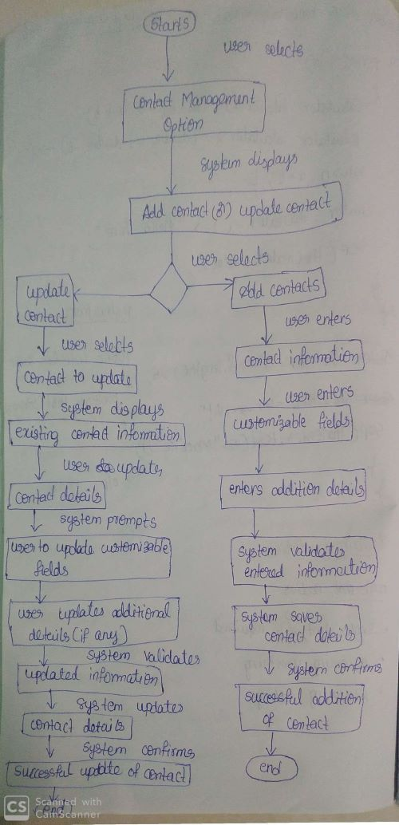

**3.1.1.2 Contact Segmentation**

1. As a User, I want the CRM to provide an AI-driven segmentation option for faster and more accurate grouping.

2. As a User, I want the ability to schedule automated contact list updates based on specific criteria.

3. As a User, I want to easily export segmented contact lists for targeted marketing campaigns.

**Acceptance Criteria:**

**Given:** Users have logged into the CRM system.

Users have the necessary permissions to add and update customer contact information.

**When:** A user initiates the process of adding or updating customer contact information.

**Then:** The CRM system presents a user-friendly interface for adding or updating contact details.

Users can input and modify customer contact information in the customizable fields.

**Flow Chart:**

➢ This flowchart outlines the process for both contact segmentation and lead tracking.

Users can choose between these functionalities.

➢ For contact segmentation, users define criteria such as industry, location, or engagement level to group contacts.

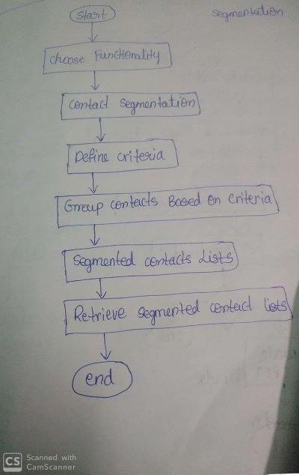

**3.1.2 Lead and Opportunity Management**

**3.1.2.1 Lead Tracking**

1. As a User, I want the CRM to automatically assign leads based on predefined criteria,

ensuring a fair distribution among sales representatives.

2. As a User, I want notifications for stalled leads, prompting timely follow-ups.

**Acceptance Criteria:**

**Given:** Users are logged into the CRM system with appropriate permissions.

CRM has a lead and opportunity management module.

**When:** Users create or update leads and opportunities.

**Then:** The CRM system offers a user-friendly interface.

Users easily manage leads, update information, and convert leads to opportunities.

**Flow Chart**:

➢ For lead tracking, users can add new leads to the system and assign them to specific

sales representatives. Additionally, users can update the status of leads as they progress

through the sales pipeline.

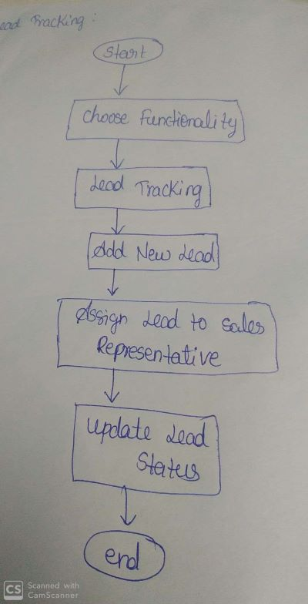

**3.1.2.2 Opportunity Management**

1. As a User, I want the CRM to provide a visual representation of deal stages, aiding in

quick decision-making.

2. As a User, I want the ability to set automated reminders for key opportunity milestones.

**Acceptance Criteria:**

**Given:** Users are in the CRM system with qualified leads.

**When:** Users decide to convert leads into opportunities.

**Then:** CRM facilitates a straightforward conversion process, enabling users to track deal stages, values, and probabilities efficiently.

**Flow Chart:**

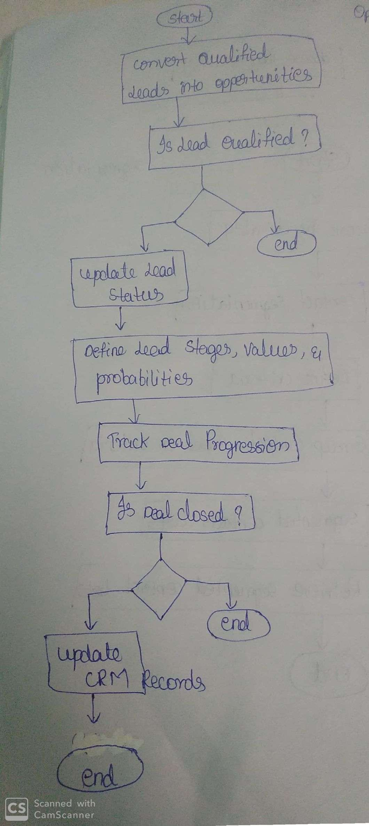

➢ This flowchart outlines the process of opportunity management.

It starts by converting qualified leads into opportunities. If the lead is not qualified, the process ends.

➢ If the lead is qualified, its status is updated, and deal stages, values, and probabilities are defined.

➢ The flow continues to track the progression of the deal. If the deal is closed, CRM records are updated, and the process ends.

If the deal is still ongoing, the flow continues until the deal is closed. Finally, the process ends.

**3.1.3 Communication and Collaboration**

**3.1.3.1 Email Integration**

1. As a User, I want the CRM to categorize and prioritize emails, helping me focus on critical communications.

2. As a User, I want the CRM to provide insights into email engagement, helping me tailor future communications.

**3.1.3.2 Team Collaboration**

1. As a User, I want collaborative spaces that include a centralized document repository for easy access to shared resources.

2. As a User, I want automated notifications for team activities to stay informed about

ongoing collaborations.

**Acceptance Criteria:**

**Given**: Users are in the CRM system with email communication needs.

**When:** Users require seamless email integration for communication tracking.

**Then:** CRM provides effortless email integration, allowing users to archive emails and attachments to customer records.

**Flow Chart:**

➢ This flowchart outlines the process for communication and collaboration within the CRM

system. Users can choose between email integration and team collaboration

functionalities. For email integration, users can send and receive emails seamlessly within

the CRM system, with the option to archive emails and attachments to customer records.

➢ For team collaboration, users can create collaborative spaces for team discussions and share calendars for scheduling team activities.

The flow ends after completing either the email integration or team collaboration process.

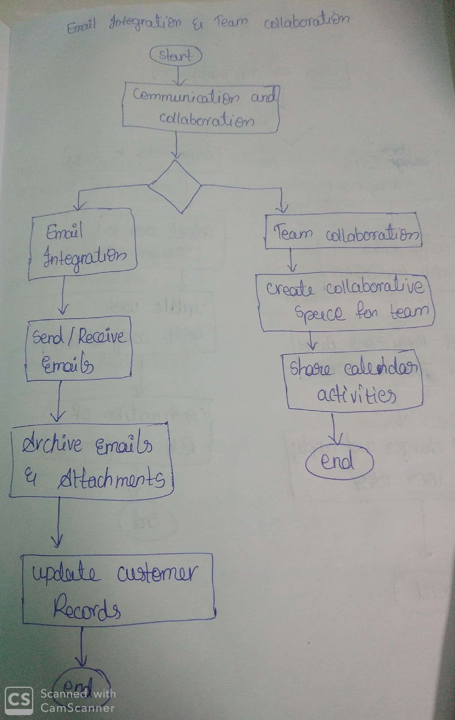

**3.2 Admin Perspective**

**3.2.1 User and Role Management**

**3.2.1.1 User Roles**

1. As an Administrator, I want the ability to customize role permissions to accommodate

unique job functions.

2. As an Administrator, I want the CRM to provide an audit trail for user role changes.

**Acceptance Criteria:**

**Given:** Administrative access.

**When:** Managing user roles.

**Then:** Define roles with specific permissions based on job functions. Assign roles to users for controlled access, ensuring security and aligning system permissions with individual responsibilities.

**Flow Chart:**

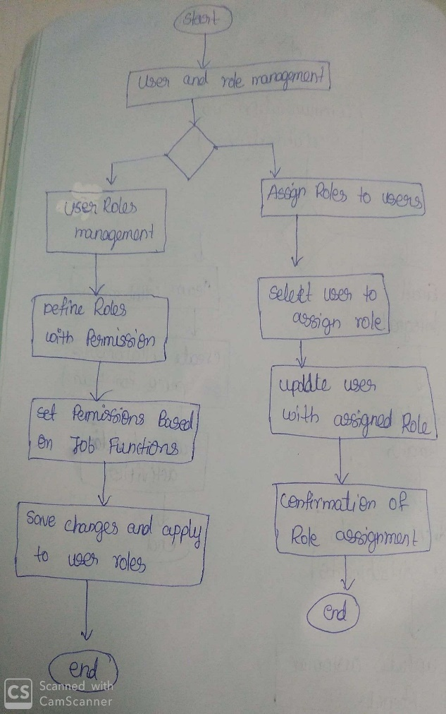

➢ This flowchart outlines the process for user and role management from an admin

perspective.

➢ Admins begin by defining roles with specific permissions based on job functions.

Then, they assign these roles to users for controlled access.

➢ Admins set permissions based on the defined roles and job functions,

and once the changes are saved and applied, the process concludes with confirmation of the role assignment. Finally, the flow ends

**3.2.1.2 User Onboarding**

1. As an Administrator, I want a user-friendly onboarding process that includes an

interactive tutorial for new users.

2. As an Administrator, I want the CRM to provide a dashboard summarizing the onboarding progress for each user.

**Acceptance Criteria:**

**Given:** New user account creation**.**

**When**: Implementing onboarding.

**Then:** Simplify onboarding with easy user account creation and setup. Provide training materials and resources to facilitate a smooth introduction for new users.

**Flow Chart:**

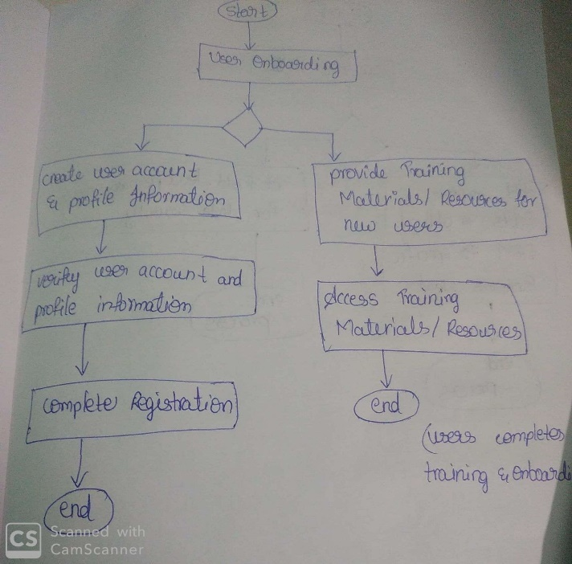

This flowchart outlines the steps involved in the user onboarding process:

**Create User Account and Profile Information**: The process starts with creating a user account

and entering profile information.

**Verify User Account and Profile Information**: The user account and profile information are verified to ensure accuracy.

**Complete Registration**: Once verified, the user registration process is completed.

Provide Training Materials/Resources: Training materials and resources are provided to the

user for onboarding.

**Access Training Materials/Resources**: The user accesses the provided training materials and resources to familiarize themselves with the system.

**End:** The process ends once the user completes the training and onboarding process.

This flowchart guides the user through the steps of creating an account, verifying information,

accessing training materials, and completing the onboarding process.

**3.2.2 Customization and Configuration**

**3.2.2.1 Custom Fields**

1. As an Administrator, I want the CRM to provide a validation mechanism for custom

fields to maintain data integrity.

2. As an Administrator, I want the CRM to support dynamic addition and removal of

custom fields without system downtime.

**Acceptance Criteria:**

**Given:** Administrative access to the CRM.

**When:** Implementing customization.

**Then:** Enable administrators to add custom fields, tailoring the CRM to specific business needs. Implement field-level permissions to enhance data security and control access.

**Flow Chart:**

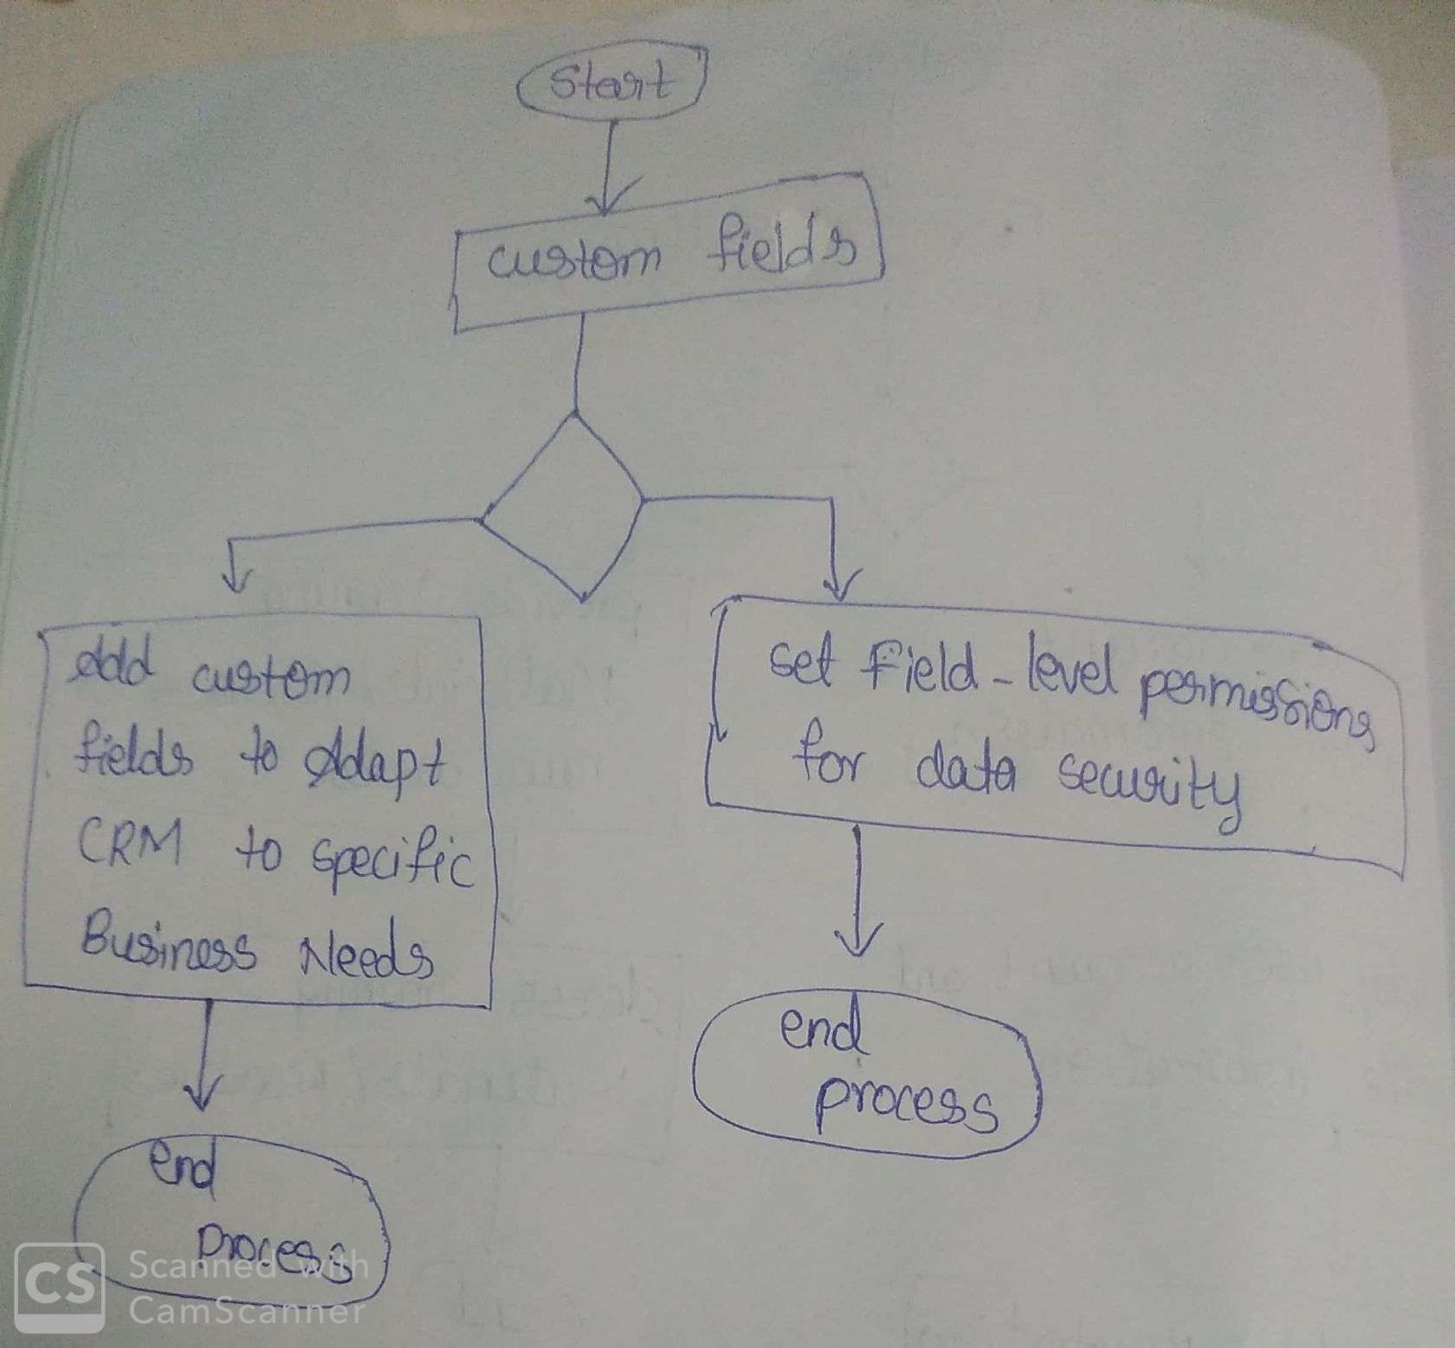

➢ This flowchart outlines the steps involved in the "Custom Fields" feature, including

adding custom fields to adapt the CRM to specific business needs and setting field-level

permissions for data security.

➢ Once the custom fields are added and permissions are set, the process ends.

**3.2.2.2 Workflow Automation**

1. As an Administrator, I want the CRM to allow the cloning of existing workflows for rapid configuration.

2. As an Administrator, I want to receive automated alerts for workflow errors, ensuring

timely resolution.

**Acceptance criteria:**

**Given:** Administrative access.

**When:** Implementing workflow automation.

**Then:** Empower administrators to create automated workflows for common processes. Define triggers and actions for each workflow, streamlining operations and enhancing efficiency.

**Flow Chart:**

➢ This flowchart outlines the steps involved in the "Workflow Automation" feature.

Administrators can create automated workflows for common processes, defining triggers and actions for each workflow.

➢ Once the workflows are created and triggers and actions are defined, the process ends.

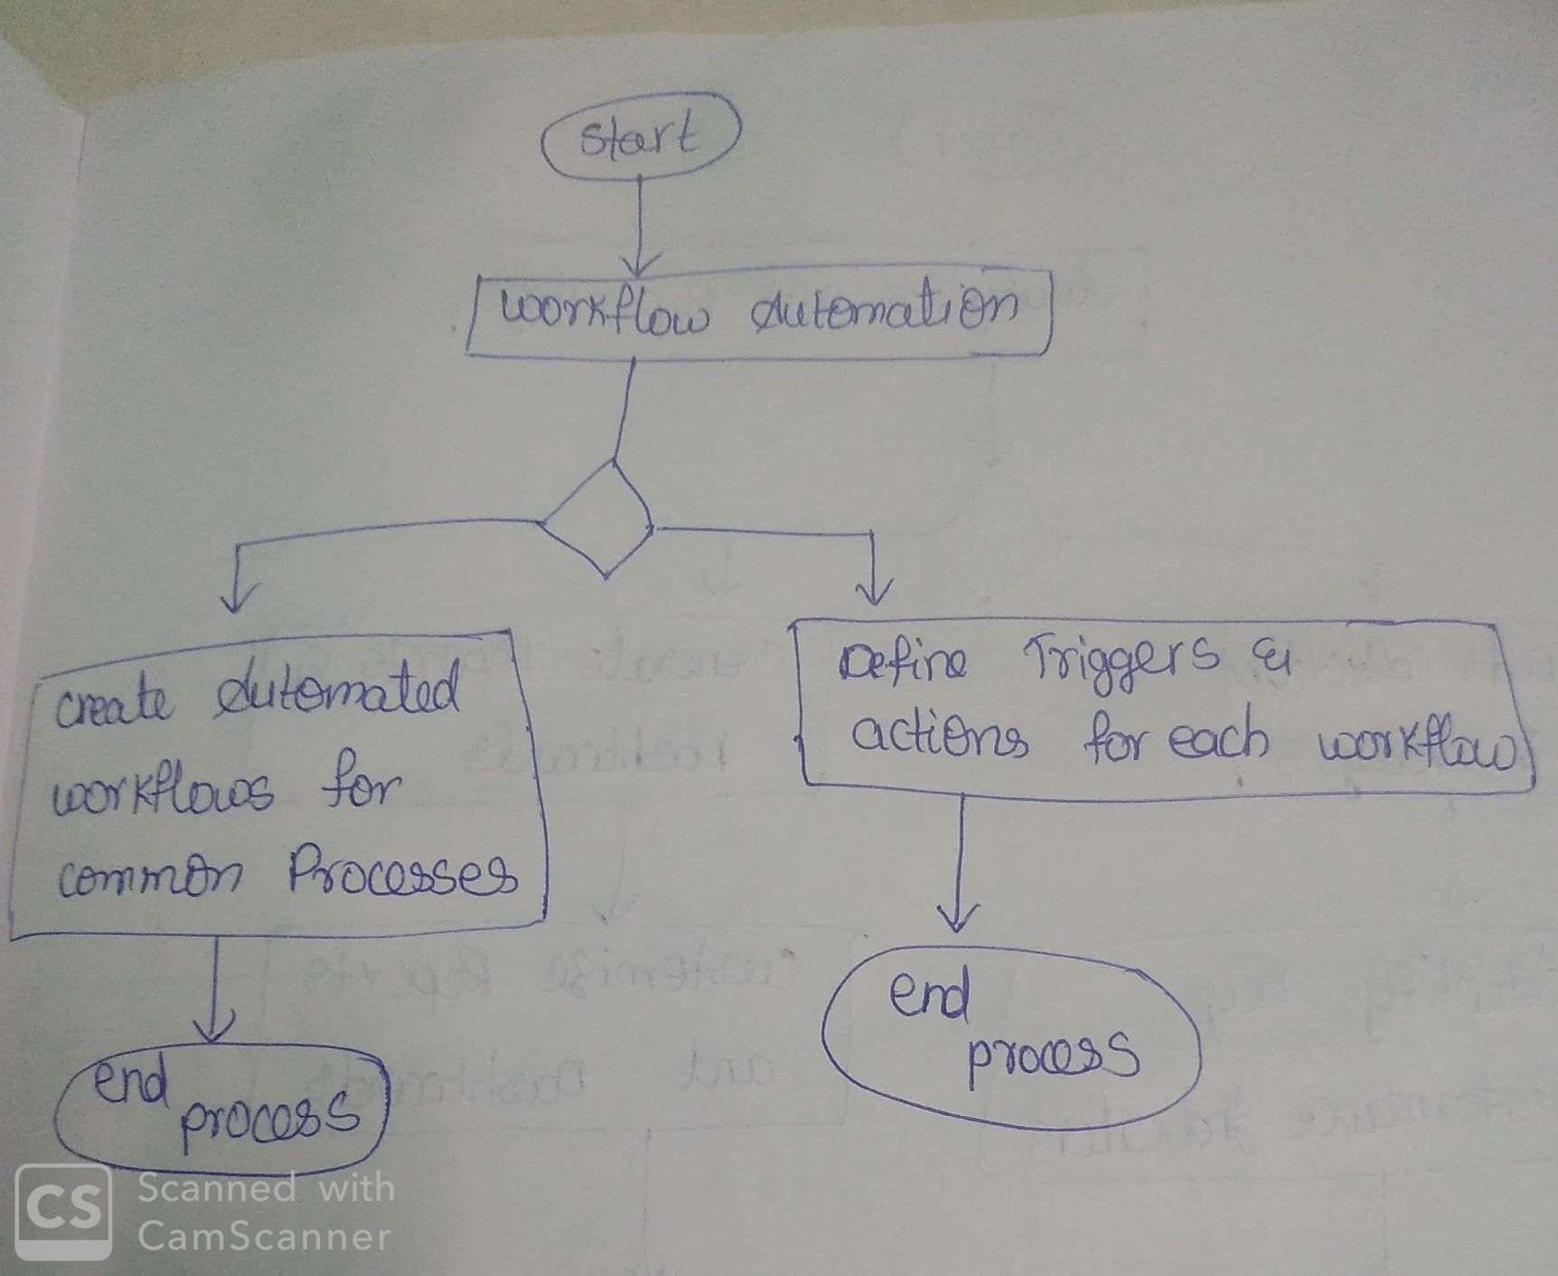

**3.2.3 Analytics and Reporting**

**3.2.3.1 Pre-built Reports**

1. As an Administrator, I want the CRM to include pre-built reports that cater to different

managerial levels, ensuring relevant insights.

2. As an Administrator, I want the CRM to offer a report scheduler for automatic generation and distribution.

**Acceptance Criteria:**

**Given**: Data from sales, marketing, and customer support.

**When:** Implementing analytics and reporting.

**Then:** Offer pre-built reports for quick insights. Enable customizable dashboards for real-time data visualization, enhancing decision-making across sales, marketing, and customer support functions.

**Flow Chart:**

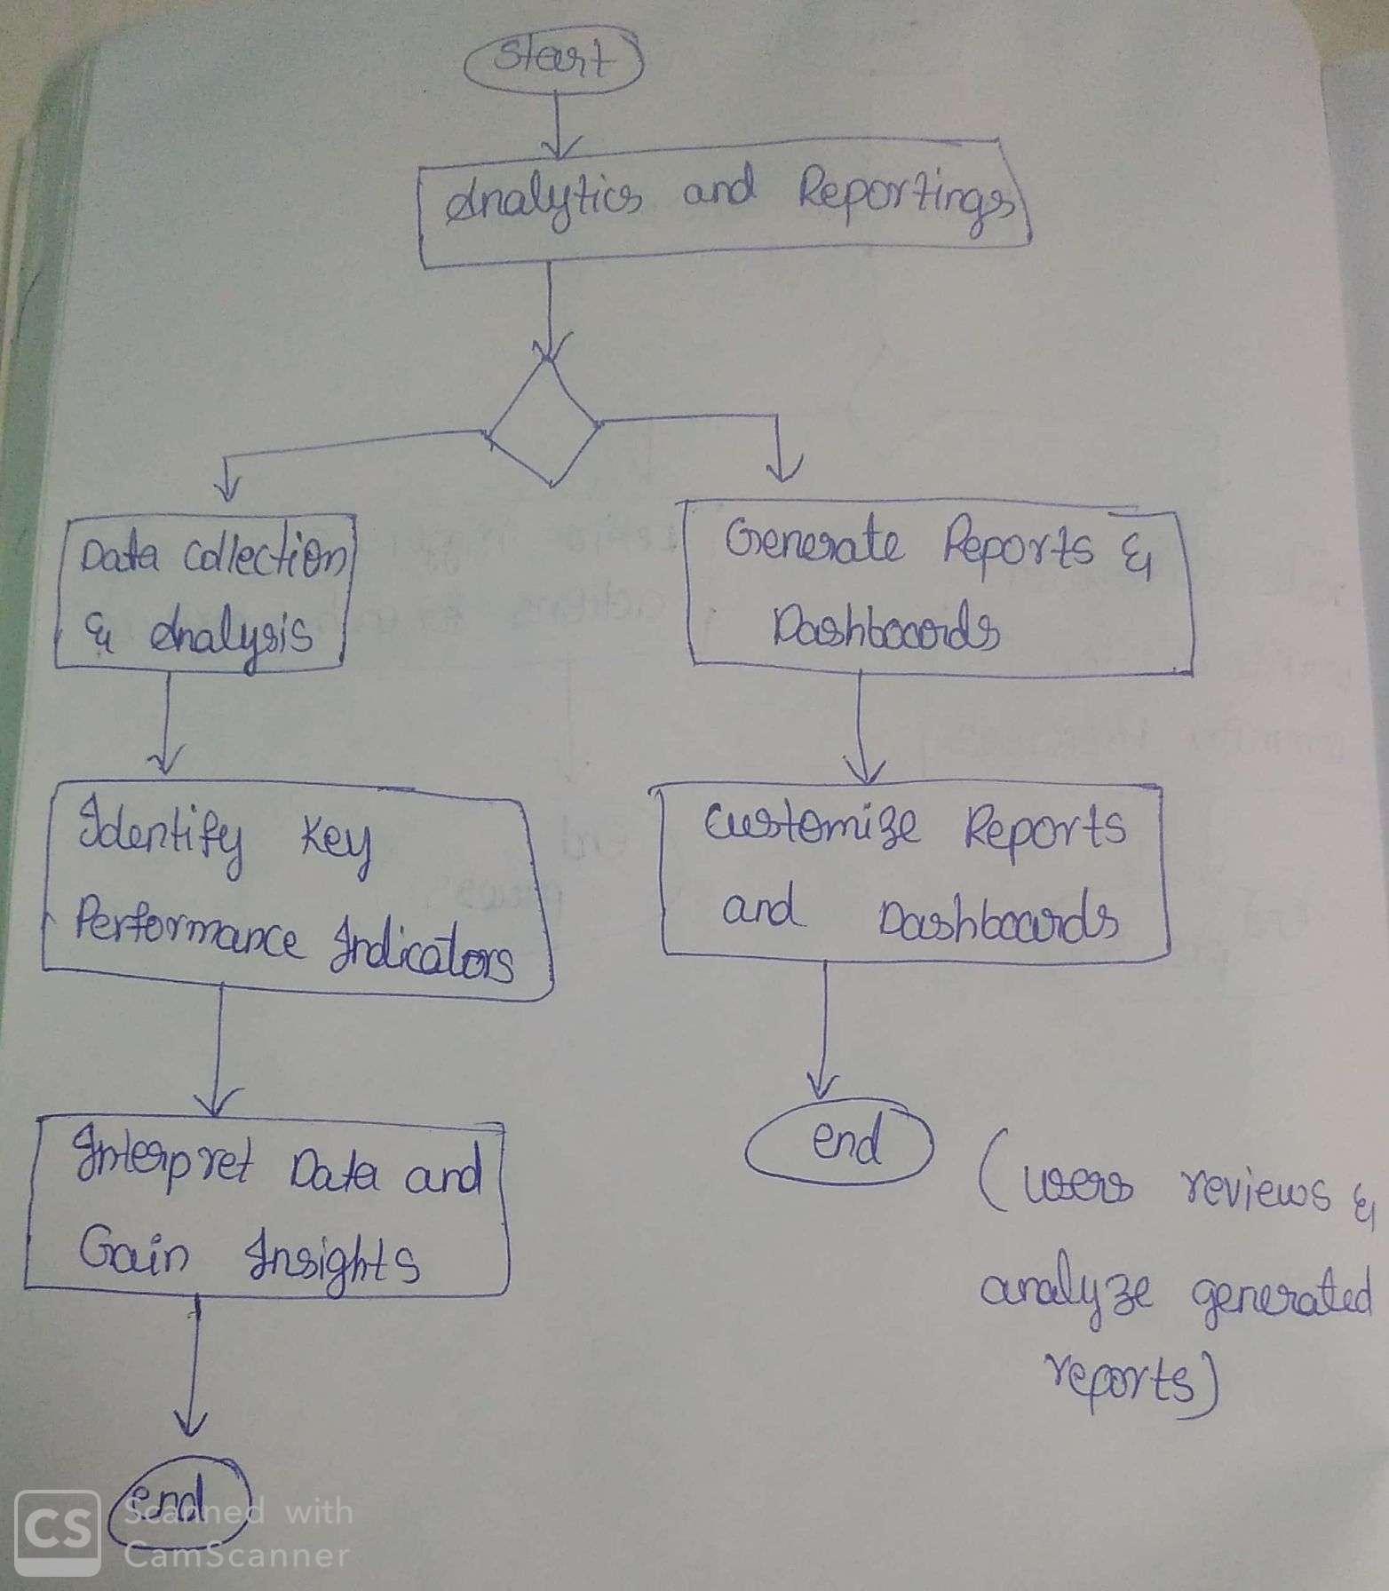

This flowchart outlines the steps involved in the analytics and reporting process:

➢ Data Collection and Analysis: The process starts with collecting relevant data from

various sources and analyzing it to identify

key performance indicators (KPIs).

➢ Generate Reports and Dashboards: Based on the analyzed data, reports and dashboards

are generated to visualize the KPIs and provide insights.

➢ Customize Reports and Dashboards: Users have the option to customize reports and

dashboards according to their specific needs and preferences.

➢ Interpret Data and Gain Insights: Users interpret the data presented in the reports and

dashboards to gain insights into business performance and make informed decisions.

End: The process ends once users have reviewed and analyzed the generated reports and dashboards.

This flowchart provides a high-level overview of the analytics and reporting process,

from data collection and analysis to interpretation and decision-making.

**3.2.3.2 Data Export**

1. As an Administrator, I want the CRM to support direct integration with popular external analytics tools.

2. As an Administrator, I want the CRM to provide a log of all data exports for compliance purposes.

**Acceptance Criteria:**

**Given:** Administrative access.

**When:** Enabling data export.

**Then:** Facilitate exports in CSV or Excel formats for external analysis. Implement automated scheduling for regular reporting, enhancing efficiency in data management and analysis.

**Flow Chart:**

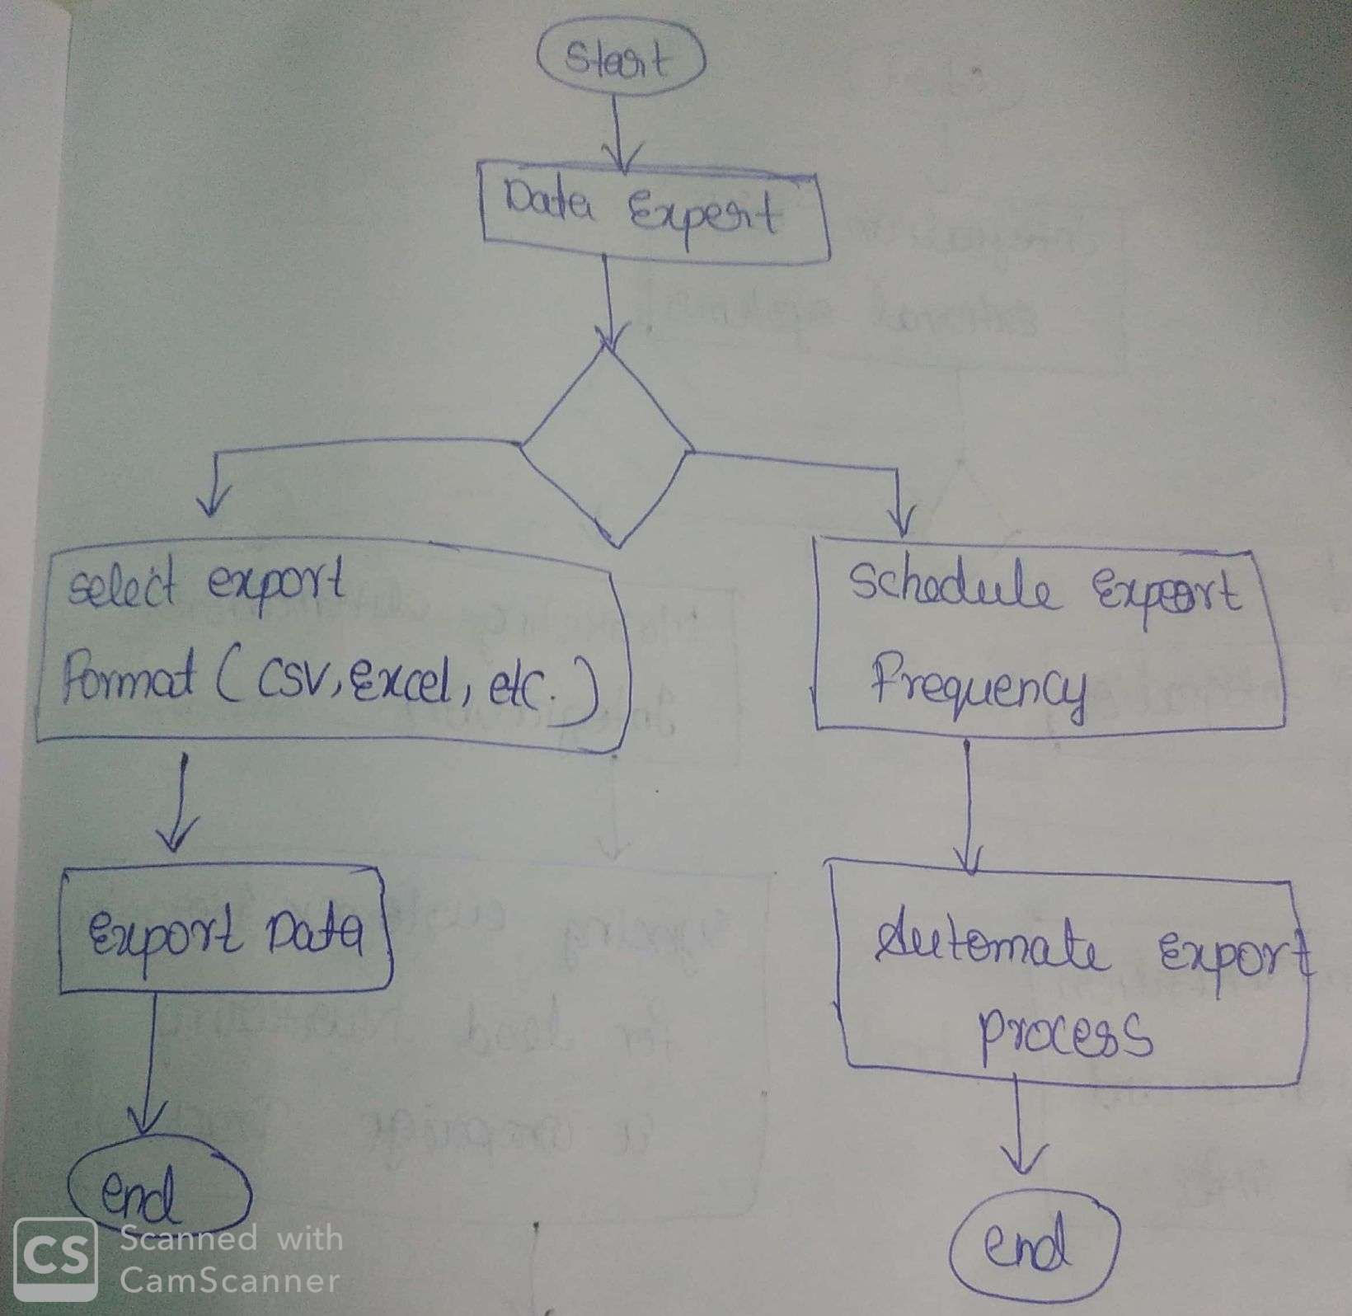

This flowchart outlines the steps involved in the data export process:

➢ Select Export Format: Administrators select the desired export format (CSV, Excel, etc.) for the data.

➢ Export Data: The system exports the data in the selected format.

➢ Schedule Export Frequency: Administrators schedule the frequency of data exports for regular reporting purposes.

➢ Automate Export Process: The system automates the data export process based on the scheduled frequency.

➢ End: The process ends once the data export has been completed.

➢ This flowchart demonstrates how administrators can export data in various formats and schedule automated exports for regular reporting purposes in the CRM system.

**3.3 Additional Details**

**3.3.1 Integration with External Systems**

**3.3.1.1 ERP Integration**

1. As a User, I want the CRM to provide real-time synchronization with ERP systems to

reflect the latest customer and financial information.

2. As a User, I want the CRM to support seamless data migration from legacy ERP systems during integration.

**Acceptance Criteria:**

**Given:** Use of Enterprise Resource Planning (ERP) systems.

**When:** Enabling seamless integration.

**Then:** Achieve unified business processes. Synchronize customer and financial data to streamline information flow and enhance overall operational efficiency.

**3.3.1.2 Marketing Automation Integration**

1. As a User, I want the CRM to provide a centralized dashboard for monitoring marketing automation tool integrations.

2. As a User, I want the CRM to support bi-directional syncing of customer interactions with marketing automation tools.

**Acceptance Criteria:**

**Given:** Use of popular marketing automation tools.

**When:** Implementing integration.

**Then:** Enable seamless lead nurturing and campaign tracking. Sync customer interactions for comprehensive insights, enhancing marketing strategy and efficiency.

**Flow Chart:**

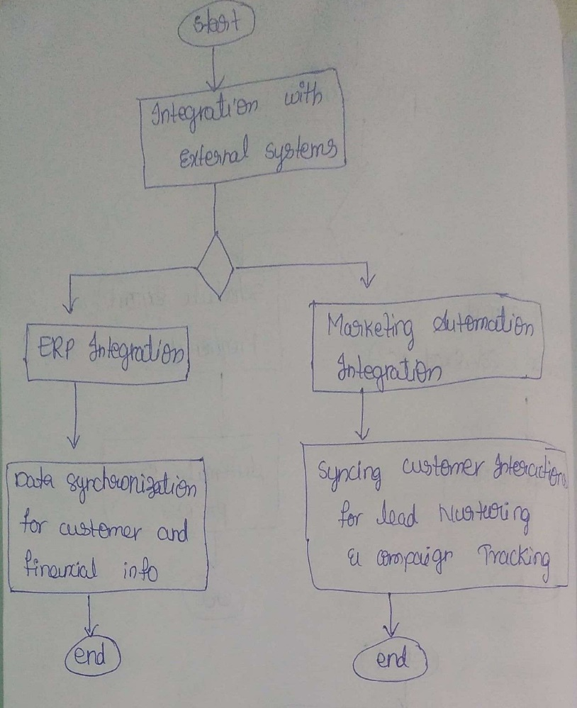

**3.3.1.3 Communication Channels**

1. As a User, I want the CRM to provide analytics on the effectiveness of communication

channels, aiding in strategy refinement.

2. As a User, I want the CRM to support automated categorization of social media interactions for streamlined tracking.

**Acceptance Criteria:**

**Given:** Multiple communication channels (email, chat, social media).

**When:** Implementing integration.

**Then:** Centralize customer interactions across channels. Capture and store communications within CRM for comprehensive customer insights and streamlined communication management.

**Flow Chart:**

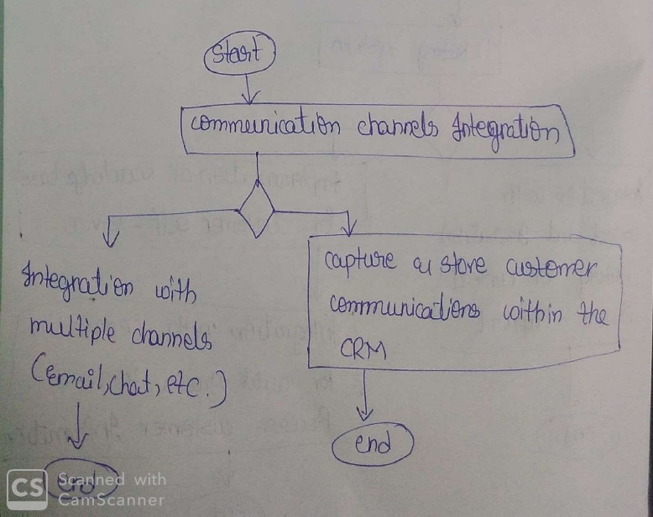

➢ This flowchart outlines the integration process with external systems, including ERP

integration, marketing automation integration, and communication channels integration:

➢ ERP Integration: The system seamlessly integrates with ERP systems for unified business

processes, including data synchronization for customer and financial information.

➢ Marketing Automation Integration: The system integrates with popular marketing

automation tools for lead nurturing and campaign tracking, syncing customer

interactions for comprehensive insights.

➢ Communication Channels Integration: The system integrates with multiple

communication channels (such as email, chat, social media) for centralized customer

interactions, capturing and storing customer communications within the CRM.

This flowchart demonstrates how the CRM system integrates with various external systems to

streamline business processes and enhance customer interactions.

**3.3.2 Customer Support Features**

**3.3.2.1 Ticketing System**

1. As a User, I want the CRM to automatically prioritize tickets based on customer

engagement history.

2. As a User, I want the CRM to provide a ticket resolution timeline for performance

evaluation.

**Acceptance Criteria:**

**Given:** Customer support requests and interaction history.

**When:** Implementing a ticketing system.

**Then:** Integrate with contact history for context-aware support. Enhance customer service efficiency and responsiveness.

**3.3.2.2 Knowledge Base**

1. As a User, I want the CRM to automatically suggest relevant knowledge base articles

based on the customer query.

2. As a User, I want the CRM to include a feedback mechanism for knowledge base articles to enhance accuracy.

**Acceptance Criteria:**

**Given:** Customer self-service needs.

**When:** Implementing a knowledge base.

**Then:** Integrate with CRM for swift access to customer information. Empower users with self-service options, improving issue resolution efficiency.

**Flow Chart:**

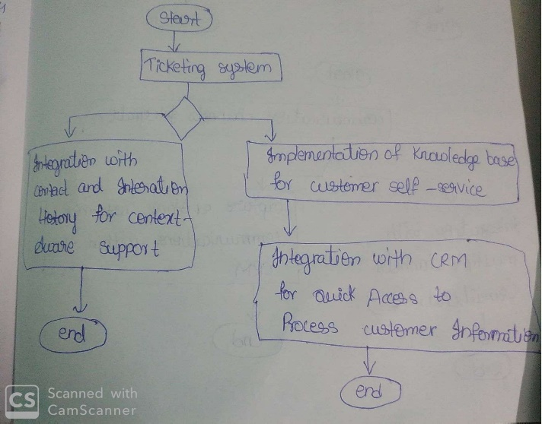

➢ This flowchart illustrates the integration of the ticketing system with the CRM's contact and interaction history, enabling context-aware support.

➢ Additionally, it shows the implementation of a knowledge base for customer self -service, integrated with the CRM for quick access to customer information while resolving issues. Once the ticketing system and knowledge base are integrated and implemented, the process ends.

**3.3.3 AI and Machine Learning Capabilities**

**3.3.3.1 Predictive Analytics**

1. As a User, I want the CRM to provide a dashboard summarizing predictive analytics

outcomes for quick decision-making.

2. As a User, I want the CRM to continuously learn from user interactions, improving the accuracy of predictive analytics.

**Acceptance Criteria:**

**Given:** Historical sales and customer data.

**When:** Applying machine learning algorithms.

**Then:** Predict potential sales opportunities and foresee customer churn. Leverage insights for proactive decision-making and strategic planning.

**3.3.3.2 Intelligent Automation**

1. As a User, I want the CRM to provide an intelligent automation dashboard for

monitoring and managing automated tasks.

2. As a User, I want the CRM to allow customization of automation rules for specific

business scenarios.

**Acceptance Criteria:**

**Given:** New data or lead information.

**When:** Data is entered or leads engage.

**Then:** Automate processes – populate fields, score leads, and trigger follow-up reminders. Integrate intelligent tools for advanced analysis. Continuously improve based on feedback and metrics.

**Flow Chart:**

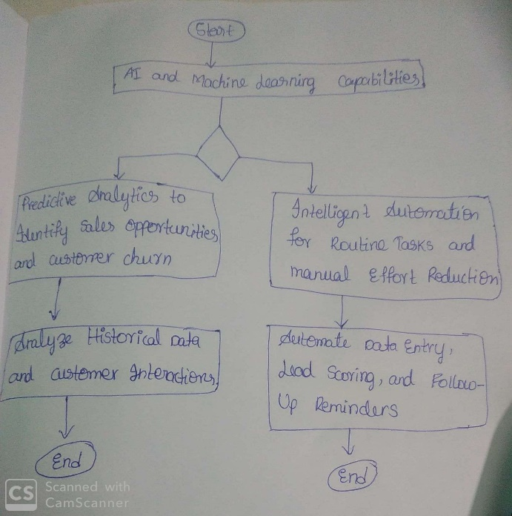

➢ This flowchart outlines the AI and machine learning capabilities within the CRM system:

➢ Predictive Analytics: The system utilizes predictive analytics to analyze historical data and customer interactions, identifying potential sales opportunities and customer churn.

➢ Intelligent Automation: The system incorporates intelligent automation for routine tasks, reducing manual efforts. This includes automating data entry, lead scoring, and followup reminders.

This flowchart demonstrates how the CRM system leverages AI and machine learning

capabilities to enhance sales processes and improve efficiency.

**4. Non-Functional Requirements**

**4.1 Performance**

**4.1.1 System Response Time**

1. As a User, I want the CRM to provide real-time monitoring of system response time for critical functions.

2. As a User, I want the CRM to generate automated alerts for prolonged system response times.

**4.1.2 Scalability**

1. As a User, I want the CRM to provide an automated scaling option based on user activity spikes.

2. As a User, I want the CRM to support load balancing for efficient distribution of user

activities.

**4.2 Security**

**4.2.1 Data** **Encryption**

1. As a User, I want the CRM to provide a security dashboard summarizing data encryption status.

2. As a User, I want the CRM to log all data access attempts for audit purposes.

**4.2.2 Compliance**

1. As a User, I want the CRM to provide a compliance report detailing adherence to data

protection regulations.

2. As a User, I want the CRM to generate automated alerts for potential compliance

breaches.

**4.3 Usability**

**4.3.1 Intuitive Interface**

**1. As a User, I want the** CRM to include a user feedback mechanism for interface

improvements.

2. As a User, I want the CRM to support personalization of the user interface based on

individual preferences.

**4.3.2 Mobile Responsiveness**

1. As a User, I want the CRM to provide a mobile app with offline functionality for fieldwork.

2. As a User, I want the CRM to support push notifications for mobile users.